Salt Lake City Research Trip

The 2024 trip to the Family Search Library is scheduled for
September 29 – October 6, 2024
________________________________________________________________________________

Explore the World’s Largest Genealogical Library with your friends from
the San Luis Obispo County Genealogical Society
________________________________________________________________________________
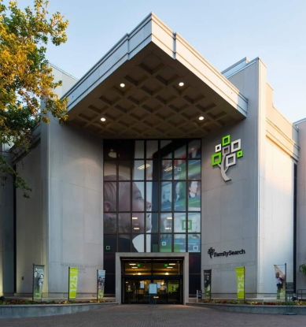

Come along on the SLOCGS Salt Lake City research trip! If you’ve gone on previous SLC trips, you know what to expect as you research throughout the world’s records. But if you have never been to the main Family Search Library, you may not know about the millions of rolls of microfilm still available, more than 500,000 books, serials and maps, and the hundreds of computers loaded with special record collections and premium web sites. And then, there is the food and the fun and companionship of your research colleagues!

Do you wonder if you are ready to go? Yes! You absolutely are! Over 500 paid and volunteer staff at the Family Search Library are waiting to help you in your ancestor search. Plus, a pre-trip class will help you prepare.

Preliminary Details
______________________________________________________________________

- In-person orientation & preparation class to prepare for your trip to Salt Lake City
- A pre-trip social to meet & exchange info with all those who are going
- Seven nights at the Salt Lake Plaza Hotel (right next door!), including free Internet
- Six days of research at the Family Search Library
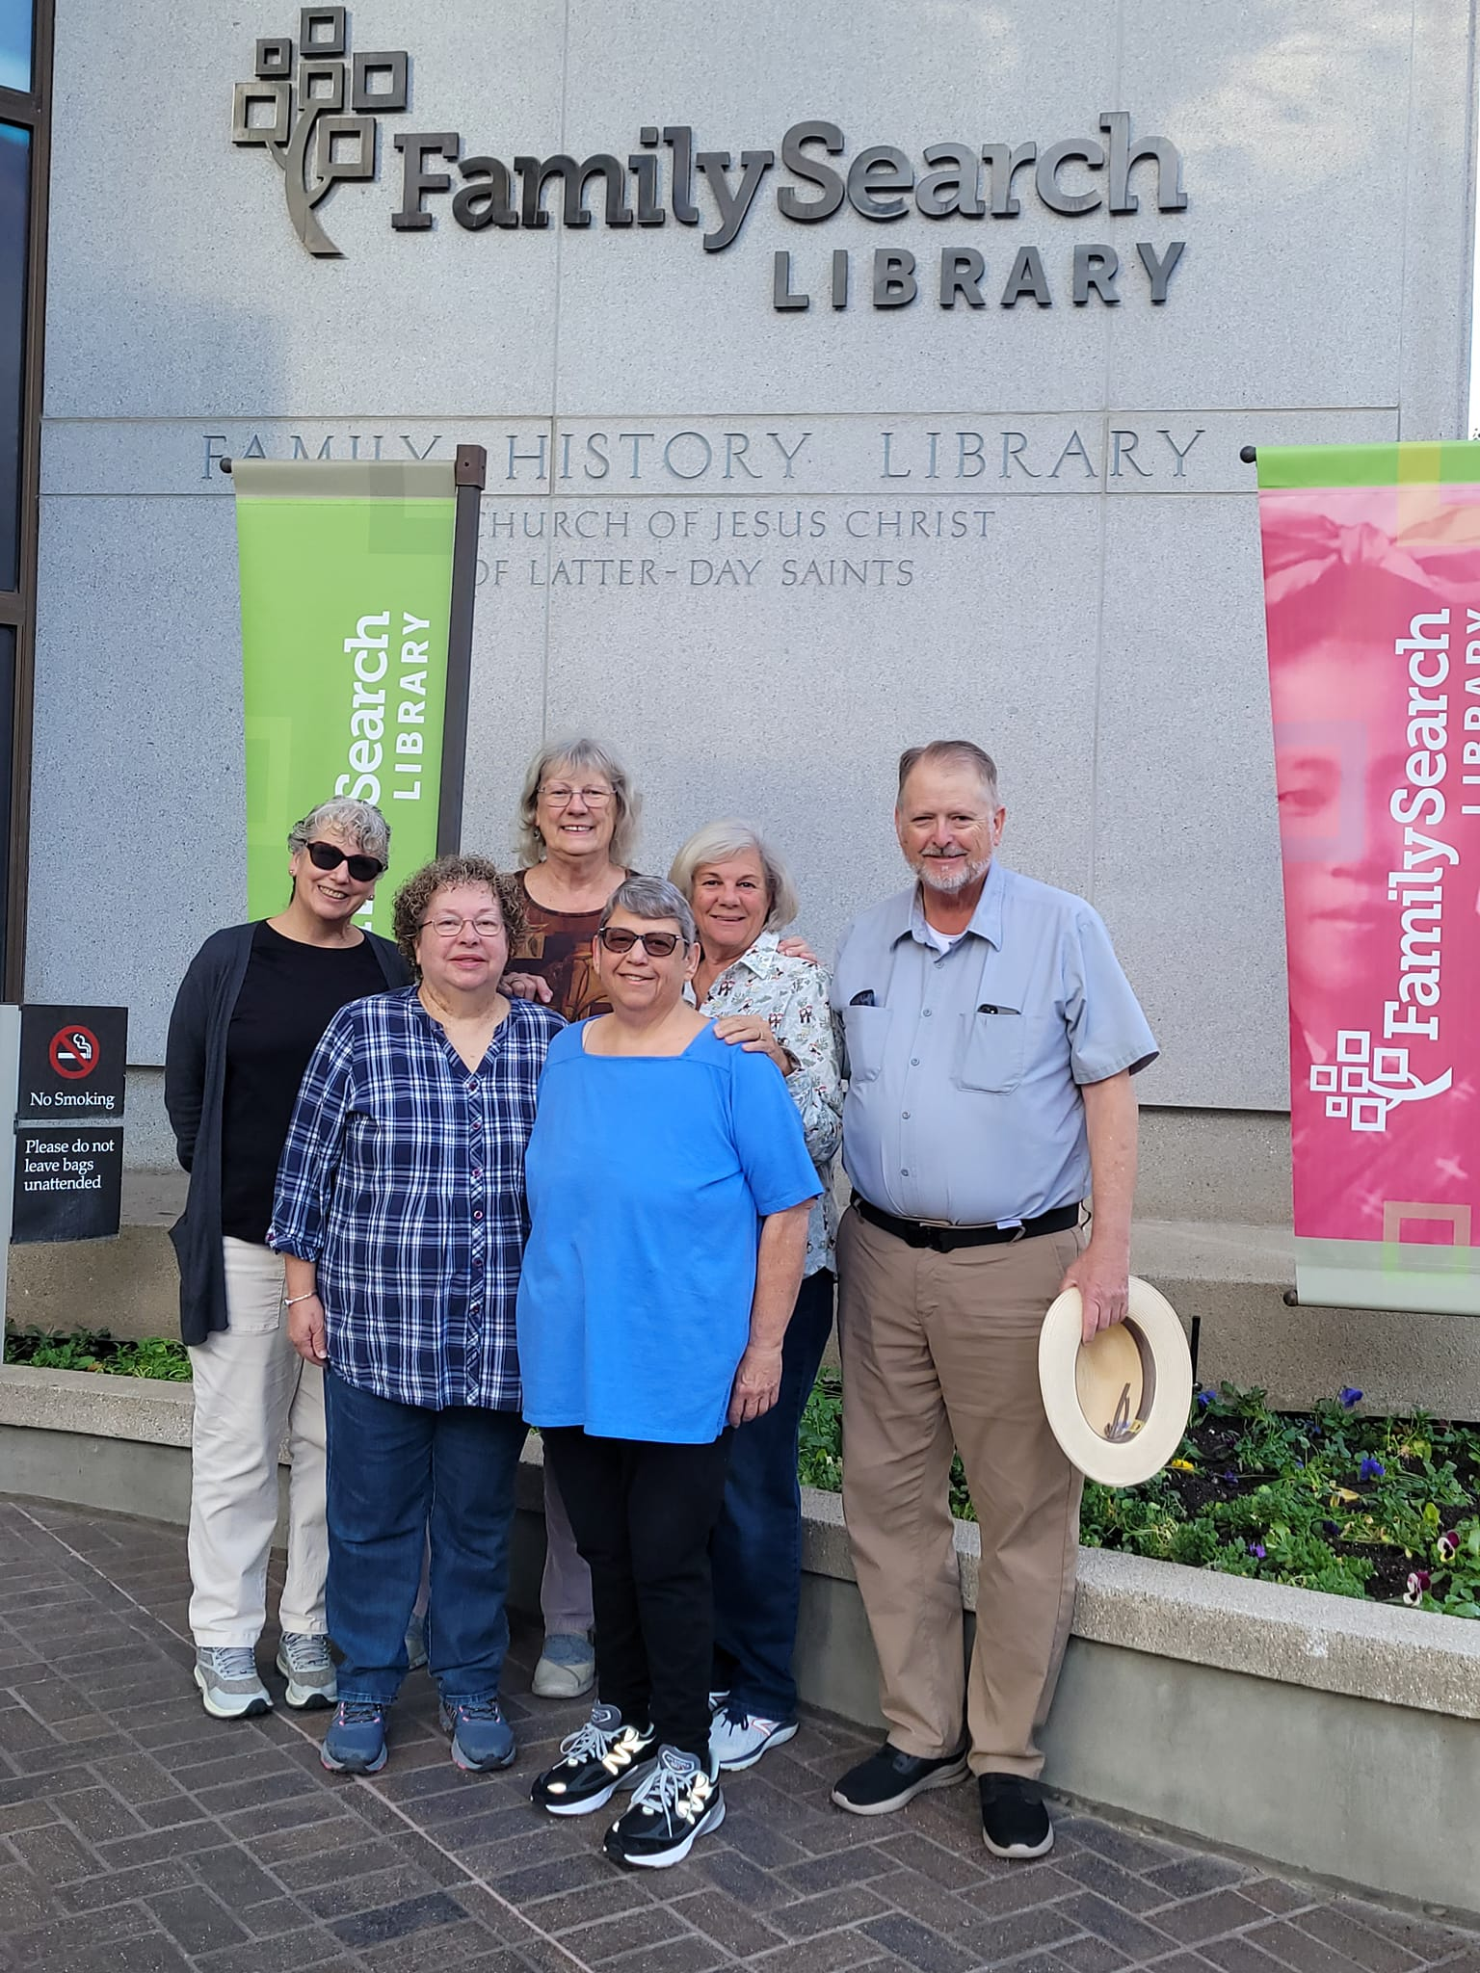
- Meet and greet on Sunday evening at the hotel
- Evening no-host dinner/social TBD
- An orientation tour of the library
- Research volunteers and specialists are available at the
Family Search Library upon request
- Free document printing (25 copies per day), lunchroom availability
- ADA handicapped access at the library
- Free self-serve digitization of your tapes, photos, slides, books,
film, and other media
- The SLOCGS tour leaders’ assistance during our research
- A nice bunch of people to hang out with during the week!
2023 Participants

Registration Fees
- Registration can be made online or print & mail the registration form with your check by August 10, 2024. Do note there are a limited number of discounted rooms available.
- $25 for SLOCGS members including SMVGS members, $40 for non-members
- For a non-researching accompanying spouse/partner, please add $20, as the spouse/partner will enjoy the group hotel rate. A non-researching spouse/partner is not eligible to attend the SLOCGS prep class.
- PLEASE NOTE: After August 20, 2024, all registration fees are non-refundable regardless of your reason for canceling.

Preparation Class

Upon receipt of your registration form and fee, we will place you on the approved list for the Research Trip Preparation Class on August 10, 2024. The prep class will focus on preparing for the best results from the research trip as well as what to bring, what restaurants and food stores are available, transportation, facilities at the library, etc. Bring questions!

Accessibility
Cabs, hotel parking ($10/day with in/out privileges), and public transit are extra fees. Salt Lake City has an excellent bus and light rail transit system, and the hotel is within the Free Fare Zone. The transit system is called TRAX and is available from directly outside the airport to across the street from the hotel for $2.50 each way with senior discount available (fare as of May 2024).

Accommodations

Salt Lake Plaza Hotel at Temple Square www.plaza-hotel.com

122 West South Temple, Salt Lake City, UT 84101 (801) 521-0130
Easy walk to the Family Search Library, right next door!

SLOCGS Group Rates, (5) of each type room are held for us:

Standard double room $100/night + tax Deluxe double room $110/night + tax

You are responsible for your own hotel reservations AND your own travel arrangements to/from and within Salt Lake City.

Contact: Richard “Rich” Williams directly at 801-606-2410 for reservations. Let him know you are with the San Luis Obispo County Genealogical Society. If you need a handicapped-accessible room, please notify the hotel.

Your FSL workstation awaits you!

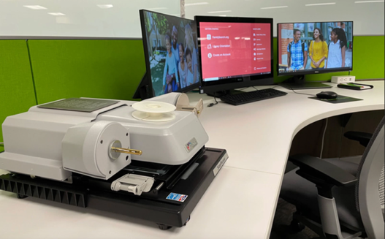

Registration form for the

2024 SLOCGS Sponsored Family Search Library Research Trip

Register online at our website https://slocgs.org/event/salt-lake-city-research-trip/

Or

Complete the form below, return with check payable to SLOCGS, and mail to:

SLOCGS President/Trip Chairperson Catherine Wathen, 837 Virginia Dr, Arroyo Grande, CA 93420

Questions? Send an email to Catherine Wathen: wathen22@gmail.com

NAME(s) _________________________________________________________________________

CELL PHONE ___________________________ EMAIL ___________________________________

Please check: ______SLOCGS/SMVGS Member $25 ______Non-Member $40
______Accompanying Spouse/Partner $20

Total Amount Included: $__________

Sharing a Room

CHECK HERE IF SEEKING A ROOM MATE _____ If you already have a roommate, there is no need to check. If seeking a roommate, we will forward contact information for anyone of the same gender also looking for a roommate. We cannot guarantee that we will find a roommate for you.

